Midterm Project

Lourdes Castleton
CS-6470

CUSTOMER CHURN PREDICTION USING MACHINE LEARNING

1. Problem Definition:
- Predict behavior in a telecommunication company to retain customers.

- Predicting customer behavior is vital for retention because it is more cost-effective than acquiring new customers and increases their lifetime value. It enables personalized experiences, helps identify issues early, and optimizes marketing strategies. By understanding behavior, businesses gain a competitive edge, build brand loyalty, and make informed, data-driven decisions that enhance long-term profitability and growth.

2. Data Collection & Exploration:

- Data Source: https://www.kaggle.com/datasets/blastchar/telco-customer-churn

- https://community.ibm.com/community/user/businessanalytics/blogs/steven-macko/2019/07/11/telco-customer-churn-1113

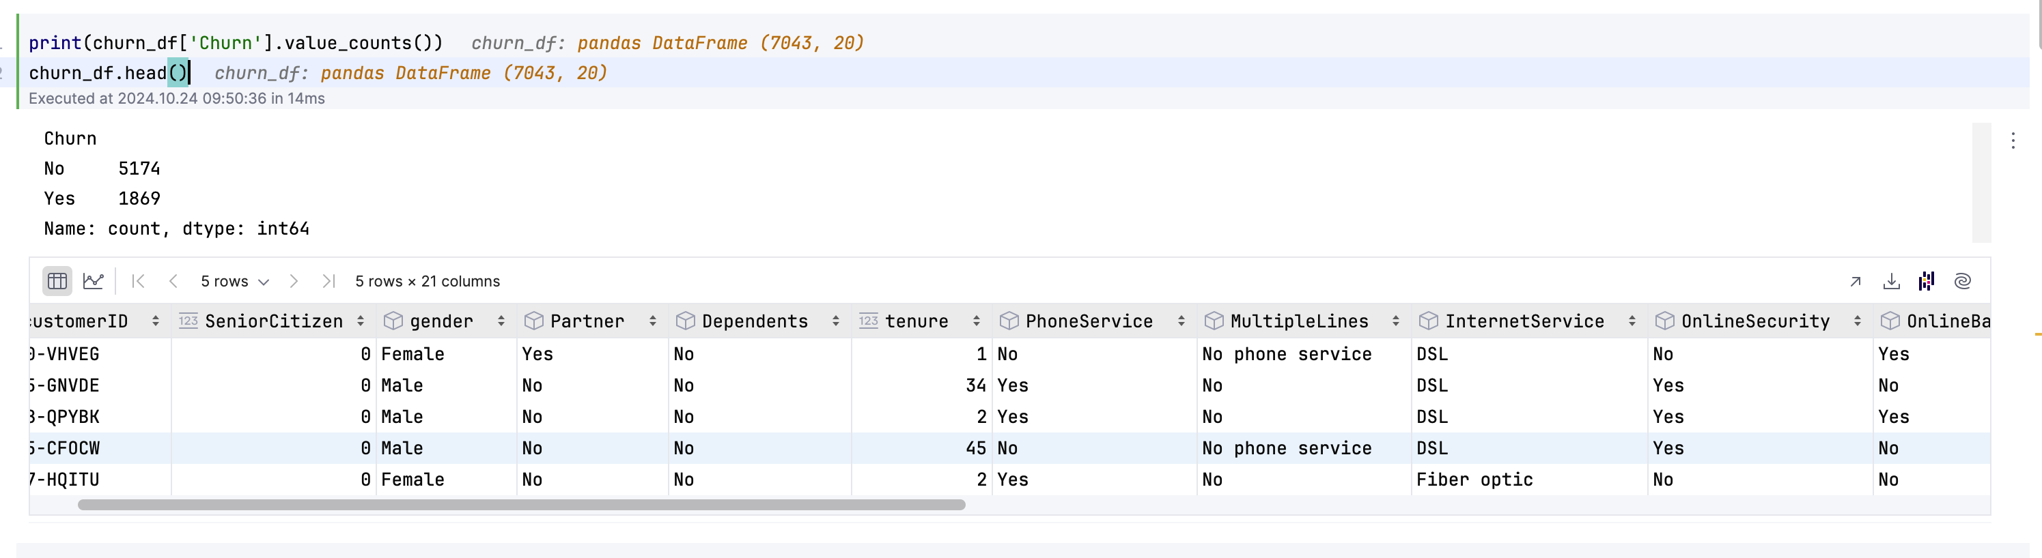
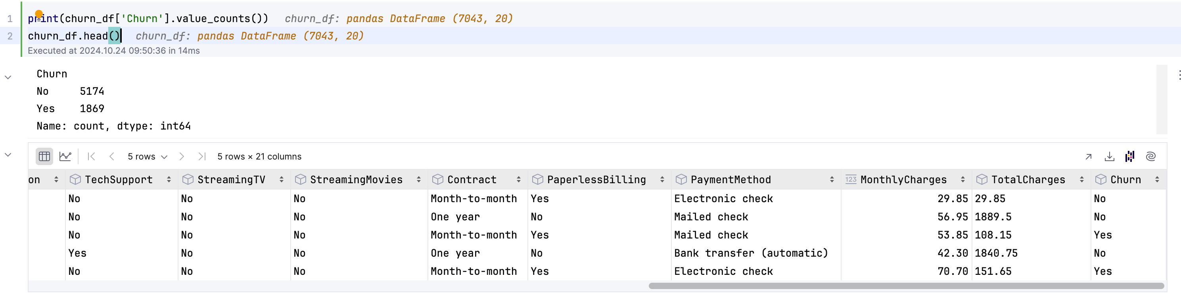

Data Exploration:
From the previous table:
-Higher monthly charges and longer tenure are associated with lower churn rates
-Customers with no internet service churn more frequently
-Heavy internet users will not churn.

Features selection: highly correlated greater than 0.8(chosen threshold) are dropped.

Data Cleaning: Data was clean, and there were no missing values; however, the distribution for the target churn was only 19%, which shows that data is not uniformly distributed.

3. Feature Engineering:

Preprocessing- Label encoding and Random Forest classifier were used.

Feature selection- PCA or Principal Component Analysis used to reduce the dimension of the data.

Handling imbalanced data= SMOTE (Synthetic Minority-Over-Sampling Technique)
I used Logistic Regression to predict customer churn.
It produces an accuracy of 81%

4. Model Building:
Model selection: Random Forest because it yields good results without fine-tuning parameters. It is versatile across different types of datasets. Random forest algorithms can measure each feature's relative importance, which is later used for feature selection.

Model training: Logistic regression was used because it's a simple model, and its output helps understand the confidence level of prediction.

Hyperparameter Tuning: Because the dataset is not too big, the method used for hyperparameter is Gridsearch.
The best parameter found was C=0.1
Best score: 80%

5. Model Evaluation:
Evaluation metrics:
Accuracy is used to evaluate the performance of the machine learning models.

The accuracy obtained using the Random Forest Classifier, after preprocessing with label encoding and applying Logistic Regression, was 81%

The accuracy obtained after using Grid Search's best parameter of C=0.1, and the best score was 80%

The accuracy obtained after applying SMOTE, preprocessing with Standard Scaler, PCA, and Logistic Regression was 77%

Finally, the accuracy obtained after applying a Random Forest Classifier, Label Encoder, XGBClassifiers, and Logistic Regression was 80%.
The XGB classifier assembler predicts and calculates the average probability
to find the optimal blend.

Cross-validation:
To perform the cross-validation, the blender variable created included the RF predict the probability and XGB probability, which were then applied to the Logistic Regression model, developing the model for the feature importances.
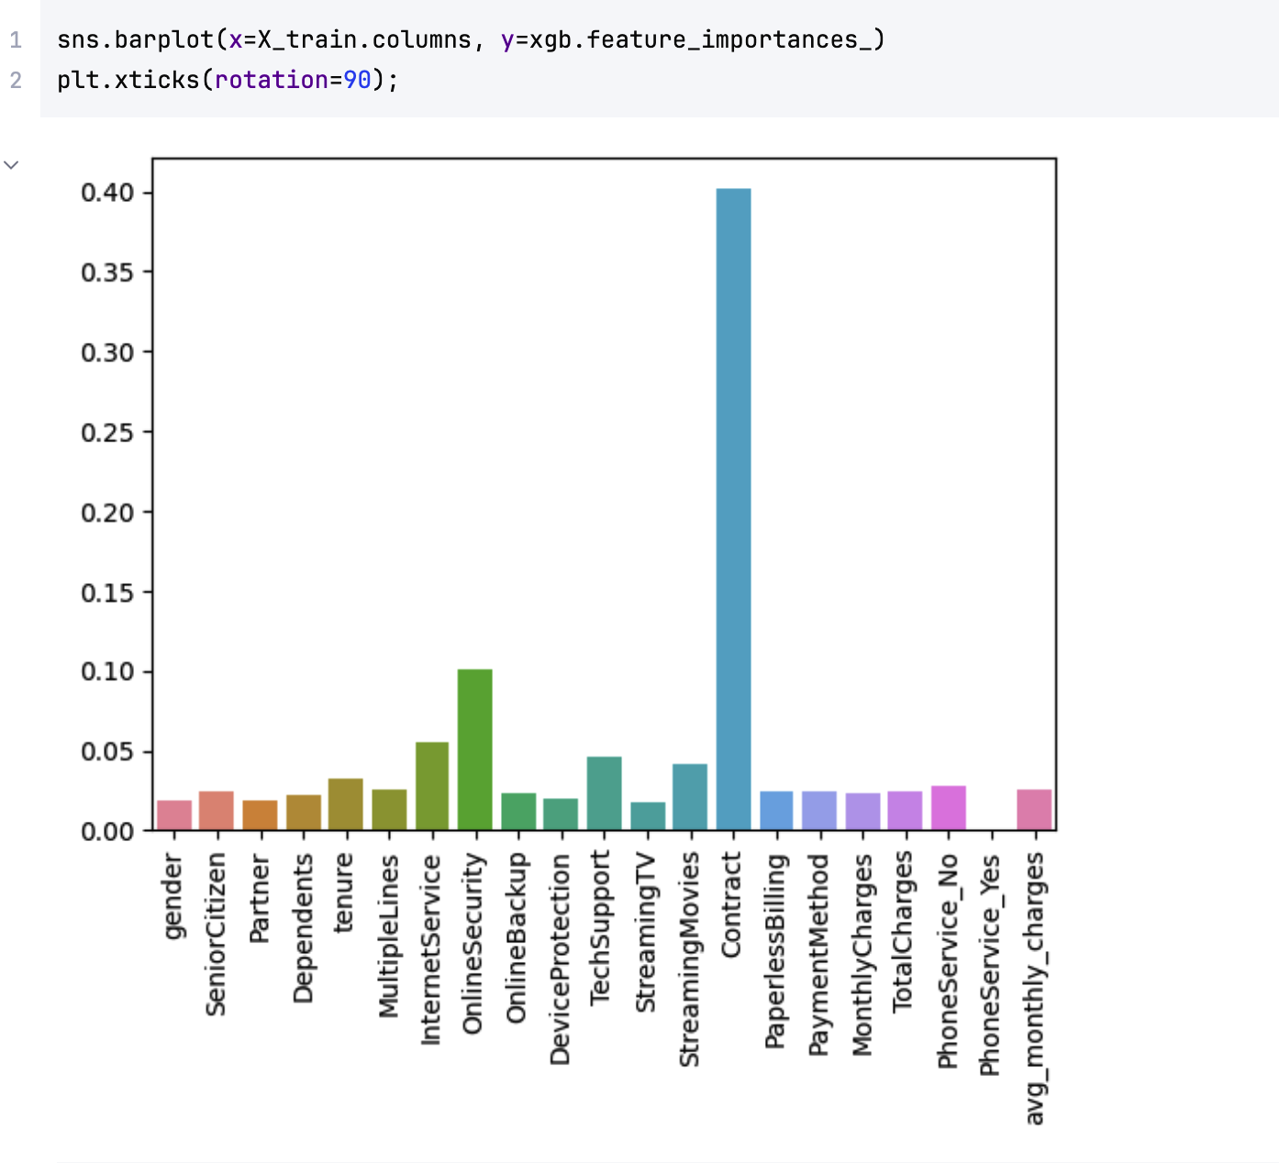
Comparative Analysis:

6. Interpretation of Results:
The visual representation of the relative importance of each feature to the logistic regression blend. The values indicate how much influence each base model had on ensemble predictions to explain individual predictions.
It was interesting to notice that the dataset was reduced after dropping highly correlated features; therefore, the accuracy decreased to the initial. The New accuracy dropped to 77% from the initial 81%. The feature selection of 77% shows the impact of feature selection based on reduced data.

